4 Roller Plate Bending Machine
Nantong Brisk CNC Co., Ltd is professional manufacturer for four roller plate bending machine. Four roller plate bending machine CNC rolling machine controlled by CNC control system. 4 roller plate bending machine can rolling round , oval, and conical shapes.
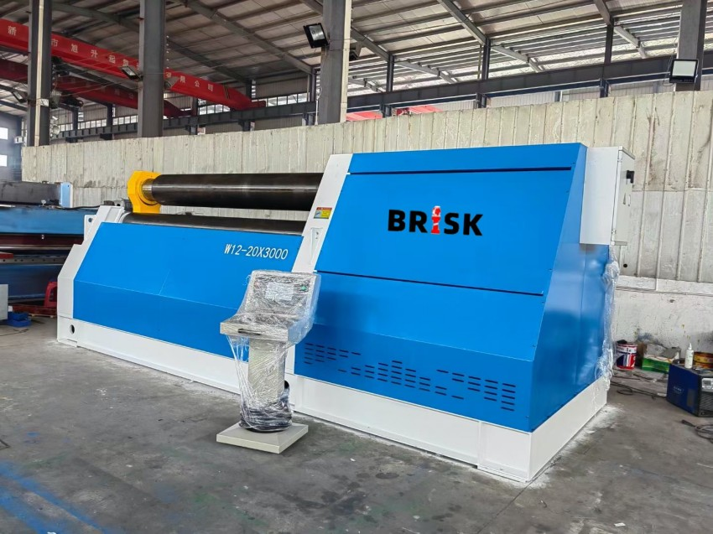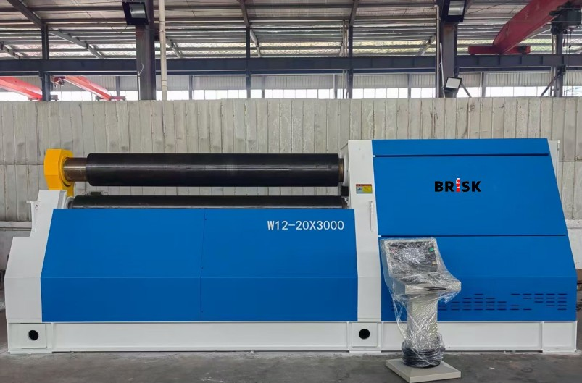

1. 4 Roller Plate Bending Machine Instruction
4 roller plate bending machine the position of the upper roller is fixed when rolling the plate, the lower roller moves upward in a straight line to clamp the steel plate, and the two side rollers move upward by the linear guide to adjust the radius of curvature of the reel, and the metal sheet can be loaded at one time without turning around. Complete the pre-bending and roll forming of the end of the sheet. 4 roller plate bending machine is an ideal equipment for rolling cylindrical, curved, conical, rectangular and other special-shaped workpieces. 4 roller plate rolling bending machine is the first choice for metallurgy, building materials, petroleum, chemical industry, water conservancy, electric power, bridge, military industry, coal, mining, shipbuilding, boiler, aviation, environmental protection, metal structure and other industries.

2. 4 Roller Plate Bending Machine Technical Datas:
The following is datas for W12CNC-20X3200 4 roller plate rolling bending machine
Model | Unit | W12-20*3200 four-roller plate bending machine
Max width | mm | 3200
The length of working roller | mm | 3250
Max thickness (central) | mm | T20*B3200*φmin800（σs≤245Mpa）
max thickness (end) | mm | T16*B3200*φmin800（σs≤245MPa）
Top roller diameter | mm | Φ400
Lower roller diameter | mm | Φ370
Side roller diameter | mm | Φ320
Rolling speed | m/min | About 4
Main motor power | kW | 22
max working pressure of hydraulic system | MPa | 19.5

3. 4 Roller Plate Bending Machine Details
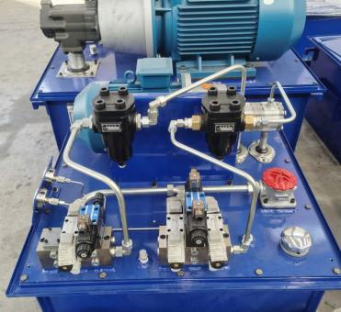  4 Roller Plate Bending Machine Hydraulic System | 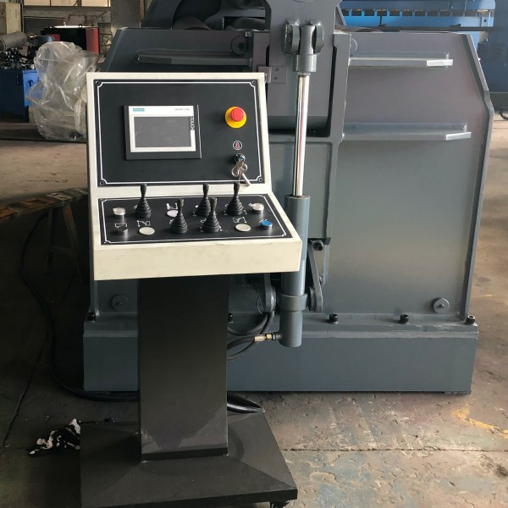  4 Roller Plate Bending Machine Control System
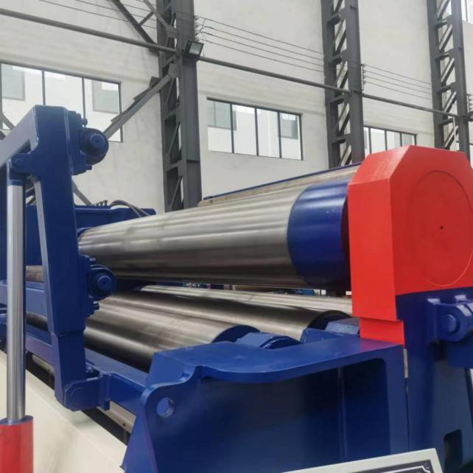  4 Roller Plate Bending Machine Rollers | 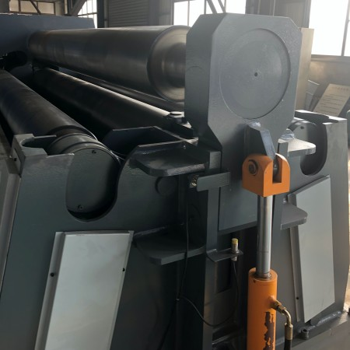4 Roller Plate Bending Machine Hydraulic drop end

4. 4 Roller Plate Bending Machine Final Products
4 roller plate bending machine can rolling round, oval, conical shapes. There’s optional cone device on the four-roller plate bending rolling machine, which can meet the requirements of users to roll the conical workpieces.
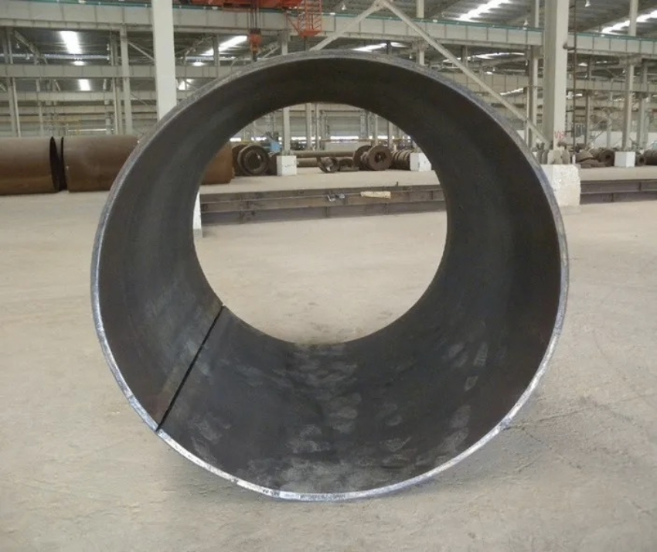
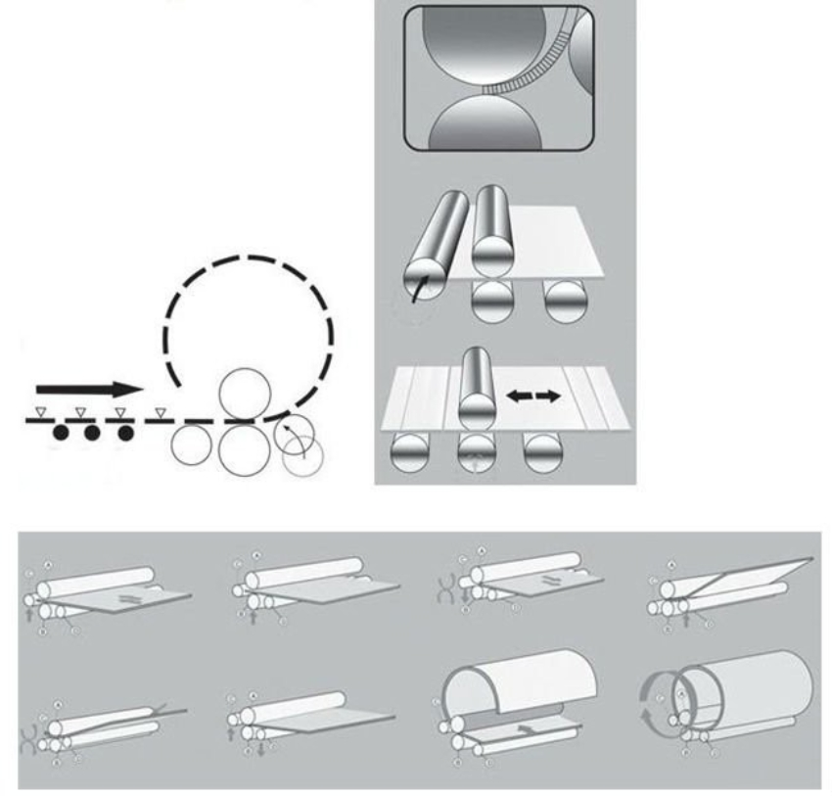

- Our Company Profile
Nantong Brisk CNC Co., Ltd located in No.52 Zhennan west road, Libao town, Nantong city, JIangsu Province. Brisk CNC is leading professional manufaturer for Hydraulic Press Brake, Shearing machine, 3 roller plate rolling machine, CNC 4 roller plate rolling bending machine, Metal iron worker, CNC press, etc. metal working machinery.

Our company has professional engenieering team. We follow the lastest design and high technology for press brake, shearing machine , and 3 roller 4 roller plate bending machine. 24 hours online after-service.

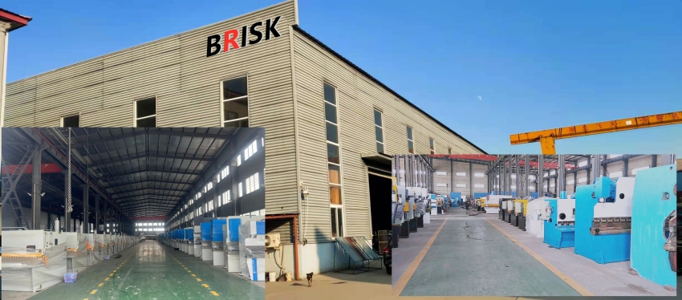

- FAQ
- Are you trading company or manufacturer?
A: We are a manufacturer for press brake, shearing machine, 3 or 4 roller plate bending machine, iron worker, etc. metal wotking machinery.

- What’s your payment term for the 4 roller plate bending machine?
A: We accept T/T, 30% deposit and balance before shippment.

- What's your delivery time?
A: Stock 7 working days after get the deposit.
25 working days for customized machine.

- What’s your warranty?
A: Our warranty for 4 roller plate rolling machine is 12 months. And tecnical support for machine whiole life time.

- How can I place order to your company ?
A. step 1: confrim the quotation which we send you.
step 2: we send you proforma invoice, and you transfer the deposit from the bank.
step 3: we start the production once we get the payment.
step 4 : arrange the shippment after the 4 roller plate bending machine finished.

